Title: The Single Market
Subject: EEC 8

1. The Single Market  A. Properties  B. Steps of implementation of the single market  a. Step 1: No tariffs  b. Step 2: No NTBs for goods  c. Step 3: Harmonization of legislation for services  C. Is the signle market working?  D. Why should the single mkt be beneficial?  a. Solow Model  b. Effects of increase in TFP  I. Static Gains  II. Dynamic Gains  c. Effects of financial sector integration  I. Theory  II. Practice: Towards a capital market union. | THE RECIPE FOR THE SINGLE MARKET (est. treaty of rome 1957)  Promoting fairness in free trade: no public subsidies or anticompetitive behaviours to national players (discrimination). Ex. Nat subsidies to consuemrs for EVs can’t discriminate wrt nation. We want a level-playing field.  Reducing economic costs  FE between currencies, then creating a single currency (Monetary Union)  Reducing physical obstacles: building/upgrading transport infrastructure (Trans-Eu Networks)  Abolishing economic frontiers:  - no tariffs, no quotas, no NTBs. - Build harmonized rules. Guarantee the four fundamental freedoms: free circulation of goods, K, services and L.  Note: We want liberalization, hence reduction of gov control and entry barriers (authorization and licenses). Note that liberalization <> privatization, state owned enterprises are not illegal but cannot receive preferential treatment (Ex. Eni 30% owned by state).  Step 1: Elimination of tariffs and quotas (60s)  Step 2: Elimination of Non-Tariff Barriers = norms on standards for safety, environment, consumer protection  - With the Treaty of Rome, the Eu started a programme for the uniformation of these standards. Limited progress (need unanimity).  - Key, In 1979 Cassis de Dijion case: Cassis is a liqueur. Ger company asked authorization to import Cassis. No authorization because Ger law requires fruit liqueur to have > 25% alcohol content (Cassis is below). Ger company sued, Nat courts referred to the CJEU for further guidance => CJEU established the principle of mutual recognition of national rules: if a product is legally produced and manufactured in a country of the Eu it can be sold in other eu countries. They did not harmonize legislation.  Step 3. Harmonization of legislation  However mutual recognition is not enough bc it does not solve the problem of non-tradable services (Need to be produced on the spot: \ex. Dentist). National regulations can block/slow down the entry of foreign though two main cathegories of obstacles:  i. cost-increasing barriers: delays at borders / need to comply with different national technical regulation and standards;  ii. market entry restrictions: measures preventing the right of establishment  Progressive harmonization:  1985: A common regulatory framework had to be set => The Commission identified 282 regulations  1987: No way of passing the needed proposals with unanimity => treaty of Rome amended by Signle European Act: from QMV to unanimity (except fp)  90s: Eu vertical (sector specific) liberalisetion of big service sectors such as civil aviation, telecommunication, energy (before nat mon protected by govs)  2004 Bolkenstein directive: the EC proposed an ‘horizontal’ directive to liberalise other services as Consultancy, Legal and Fiscal advice, etc following a ‘country of origin principle’ (similar to mutual recognition). Were the directive approved, a dentist who is practicing in Poland, can offer her services in Ger subject to the Polish legal framework (eg, taxation). The EC’s proposal was labelled as “ultra-liberal”, a “social dumping” with competition from low tax, low welfare countries.  2006 Service Directive: EC revised proposal passed. A dentist who is legally practicing in Poland can offe services in Ger only if authorized by Ger authorities and is subject to the Ger legal framework (taxes). Today, if you produce a car in Poland with Polish workers, paying Polish salaries, seriveces (ex. electricity) and taxes, you can sell to Ger with no restrition. But, if you want to sell a Polish service you have to follow the Ger rule.  + make it easier to get authotization: member states have to be more ‘business friendly’ by simplifying procedures and abolishing restrictive measures. In the same years the EU introduced a system of automatic recognition of professional qualifications for nurses, doctors and introduced the European Professional Card (EPC).  2018 Geoblocking: still, services provided by online platforms can create mkt fragmentation. Geoblocking happens when online sellers restrict online cross-border sales based on nationality/ residence (ex. deal just for Ger mkt, not accessible to France citizen). In 2018 the EU adopted a regulation to ban unjustified geoblosking. *copyright protected content is excluded from the scope of the regulation.  Is the single market being transposed correctly?  Directives require the adaptation of the national legislation. The EC regularly monitors the extent of the transposition deficit => Poor results. For the most controversial legislation the EC uses regulations (to be enforced to the letter).  Prove the single market is beneficial: use the Solow Model  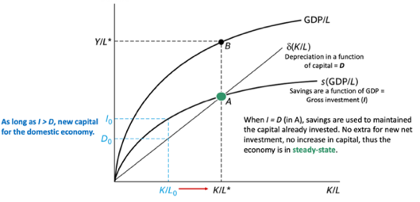  a. General framework  i. GDP as a funct of : L, K and TFP => Y = TFP * K^{α} * L ^{(1-α)}.  ii. L is fixed and K moves.  iii. Deprecciaiton function is as δ(K/L)  iv. The savings function = Investment function = s(GDP/L)  Eq condition: as long as I > D new capital for the domestic economy => higher output, higher labor productivity. As I = D we reach eq!  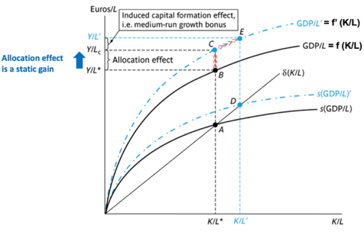  b. Integration leads to an increase in TFP trhough:  I. Static Gains (SR): for the same level of capital/level you have higher GDP  Integration creates winenrs and losers, now efficient firms serve a larger mkt, with higher room both for specialization and economies of scale. This shifts the GDP/L curve.  II. Dynamic gains (MR) / Growth effects: lt benfit of K accumulation  The shift up in the GDP/L curve also shifts up the S curve since the fixed saving rate now applies to higher output. Now we are at C, I > D, hence the economy accumulates Capital -> economy’s K/L ratio starts to rise => higher output  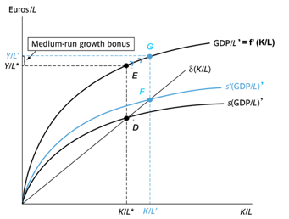  c. Effects of financial sector integration  i. Theory  Imagine you can bolster the efficiency of the fin sector through k markets integration (Before: Ita banks for Ita clients, Spa banks for Spa clients etc…)  If the efficiency of the fin sector improves => the marginal productivity of k rises => and thus more k/ unit of output is brought ( K ↑)to the market. This vields a hipher investment rate: s'> S  ii. Practice:  Free circulation of K is one of the four pillars of the common market since 1957, however the financial sector in the EU is still fragmented (ex. different stock exchanges) => low competition, no economies of scale, less efficiency!  The Commission launched a capital markets union (CMU) as there is the need to face econ crises, finance the green and digital transitions. Main points:  Making companies more visible to cross-border investors Establishing a European single access point to all relevant financial information), Supporting access to public markets: Making listing cool again, Empowering citizens through financial literacy, Improving overall price transparency across stock exchanges.

